# Section 1

## Project Set up

### Lab 1.1 - Using Templates

From your Domino home screen, scroll down to see **Jumpstart your work with a Project template**. Click the **View details** below the **mlops-best-practices-template** text. Review the details and click **Create Project.**

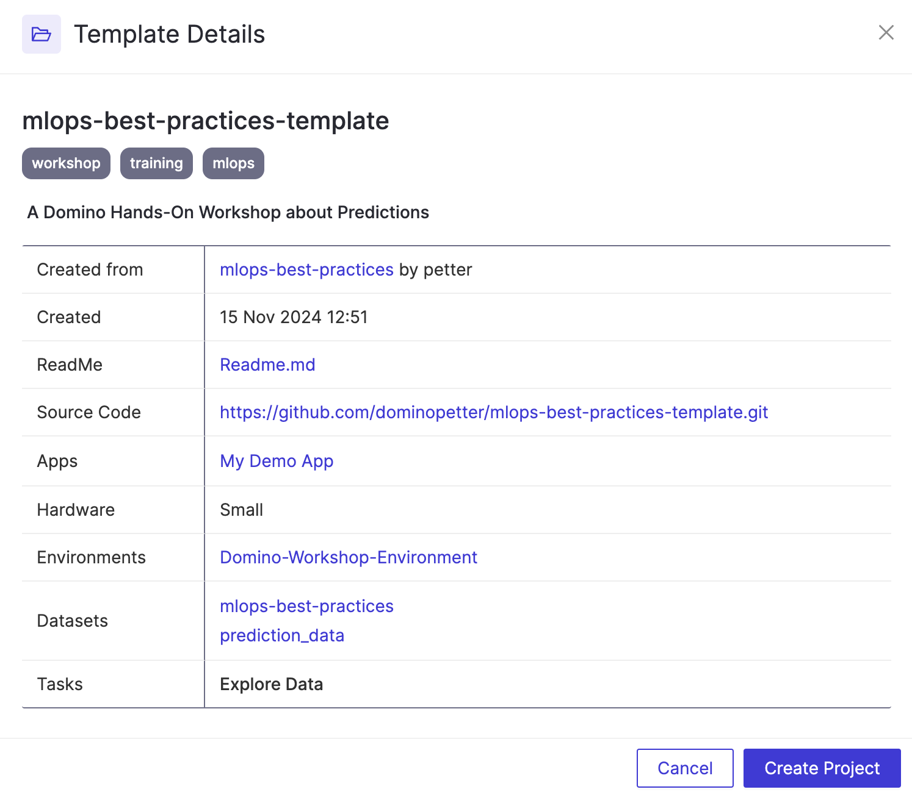

Please give your project a unique name using **FirstName-LastName**. Also, ensure the **Public** circle is checked. This is important so the instructors can assist you in case of an issue. Finally, click **Next**.

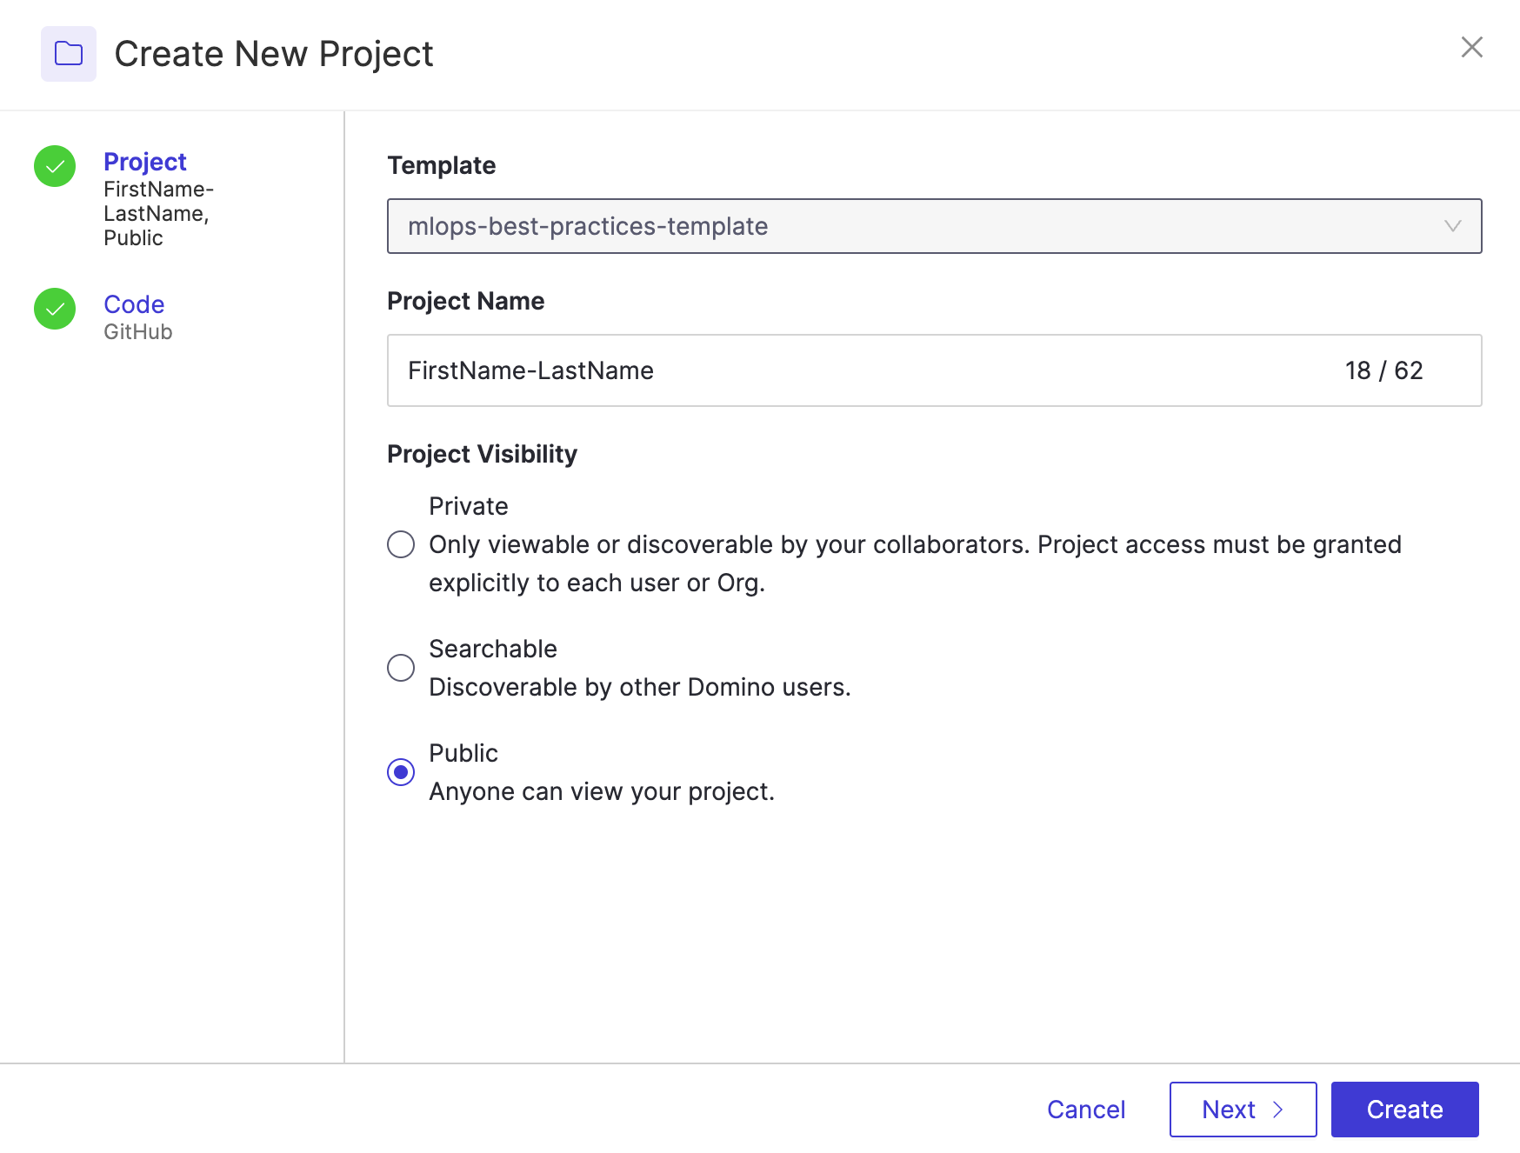

Next, fill in the highlighted parts, as shown in the following screenshot (ensure you use the same Repository Name as your previous project name). Finally, click **Create**.

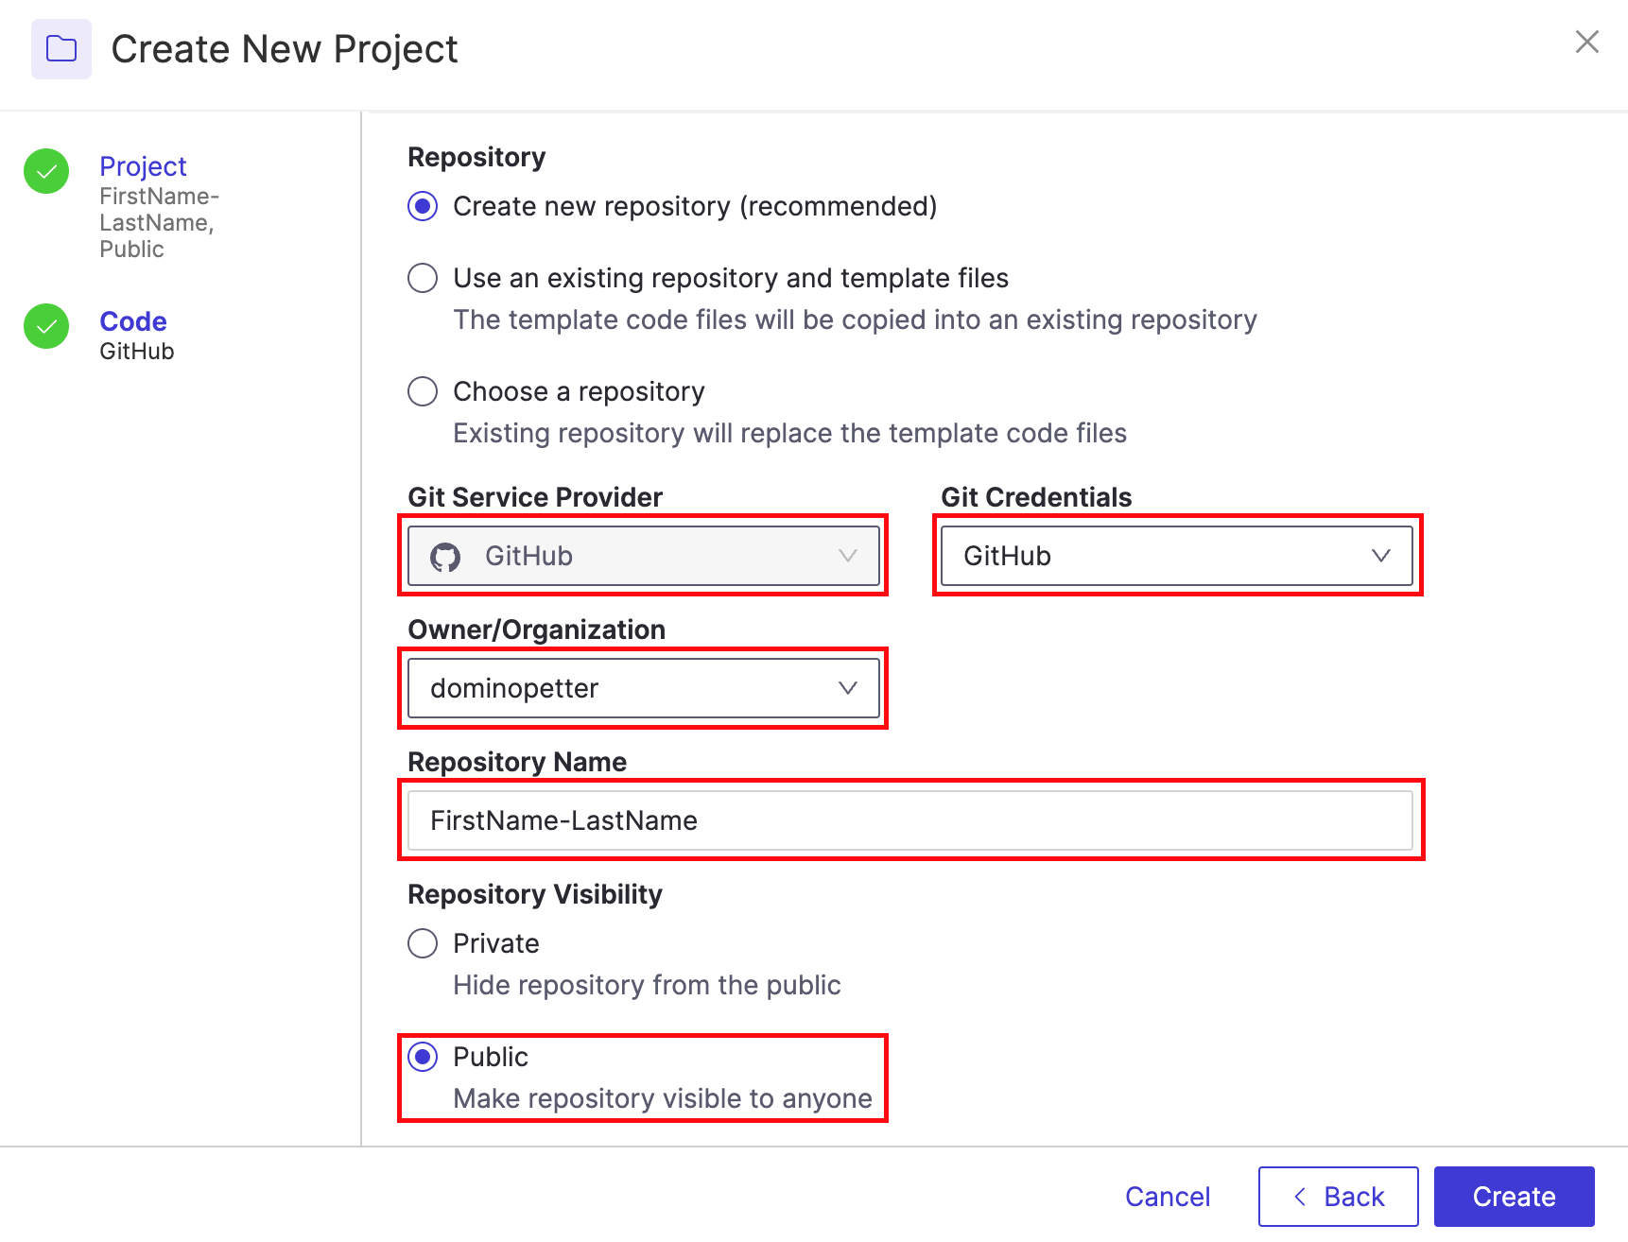

In your new project, go to the **Settings** pane.

View the default hardware tier and compute environment - ensure they are set to **'Small'** and '**Domino-Workshop-Environment**' respectively. This was pre-defined in my Template.

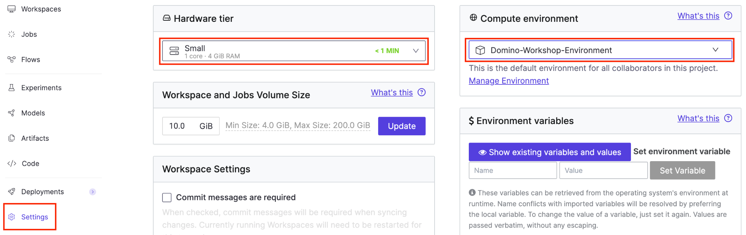

Go to the **Access & Sharing** tab and add your instructor or another attendee as a collaborator in your project.

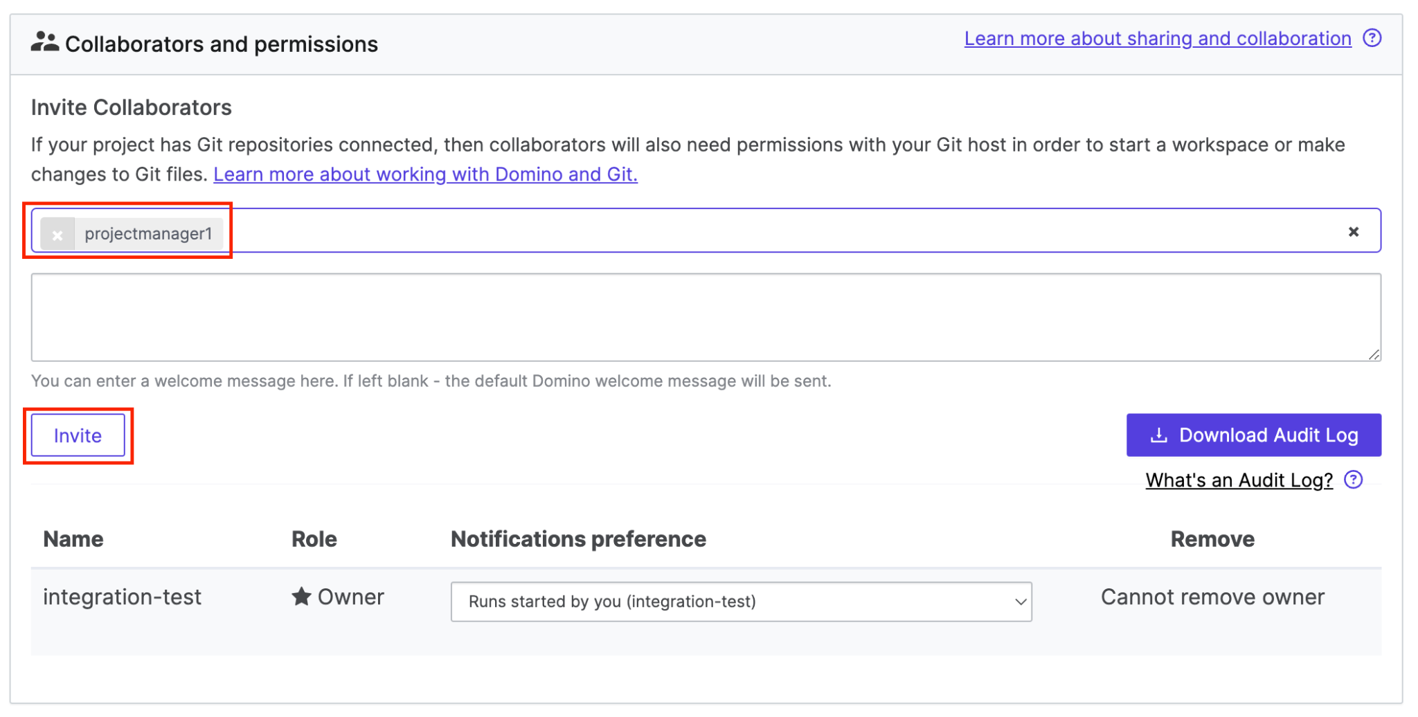

Change their permissions to **Results Consumer**.

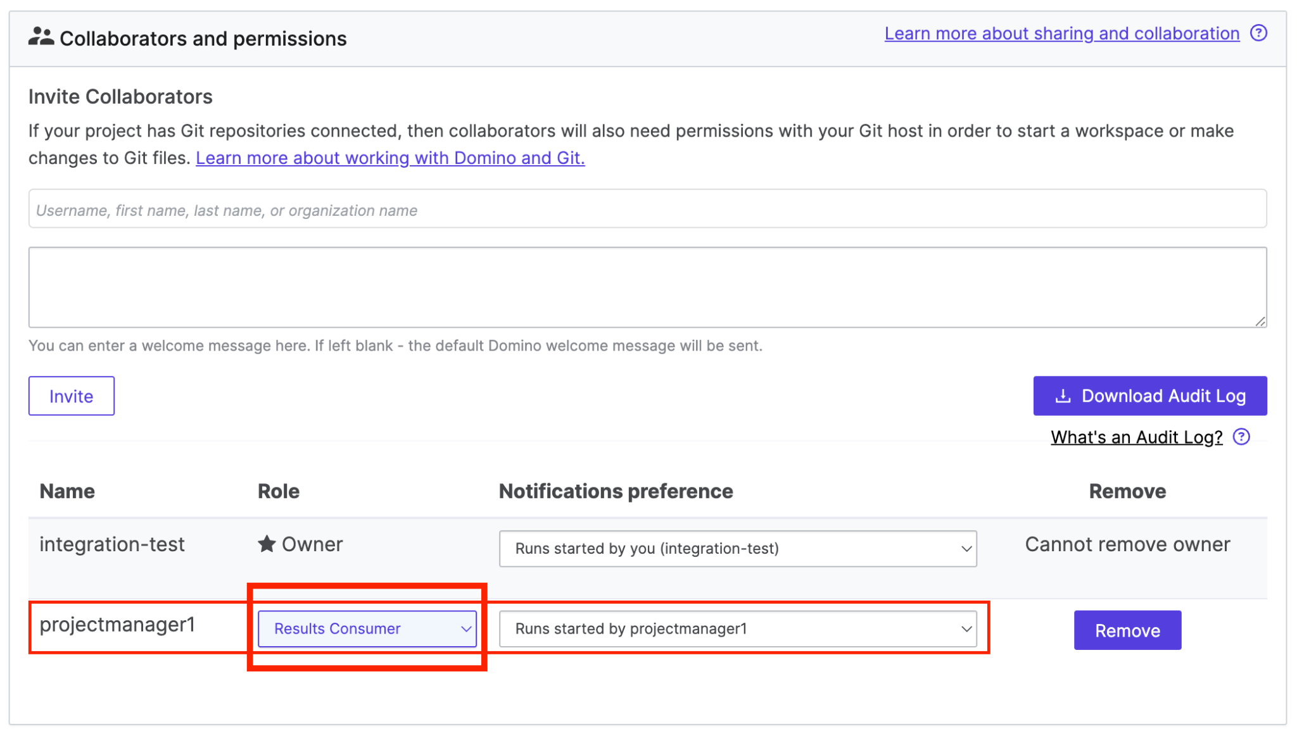

We need to add one **Environment variable**. Click the **Hardware & Environment** tab and fill in **Name and Value** under **Set environment variable**.

* **Name :** MLFLOW_NAME
* **Value :** FirstName-LastName

### Lab 1.2 - Defining Project Tasks

Click back into the Overview area of your project. Then, navigate to the **Tasks** tab.

You’ll see one **Task**; assign it to yourself by clicking the dropdown menu and choosing your name.

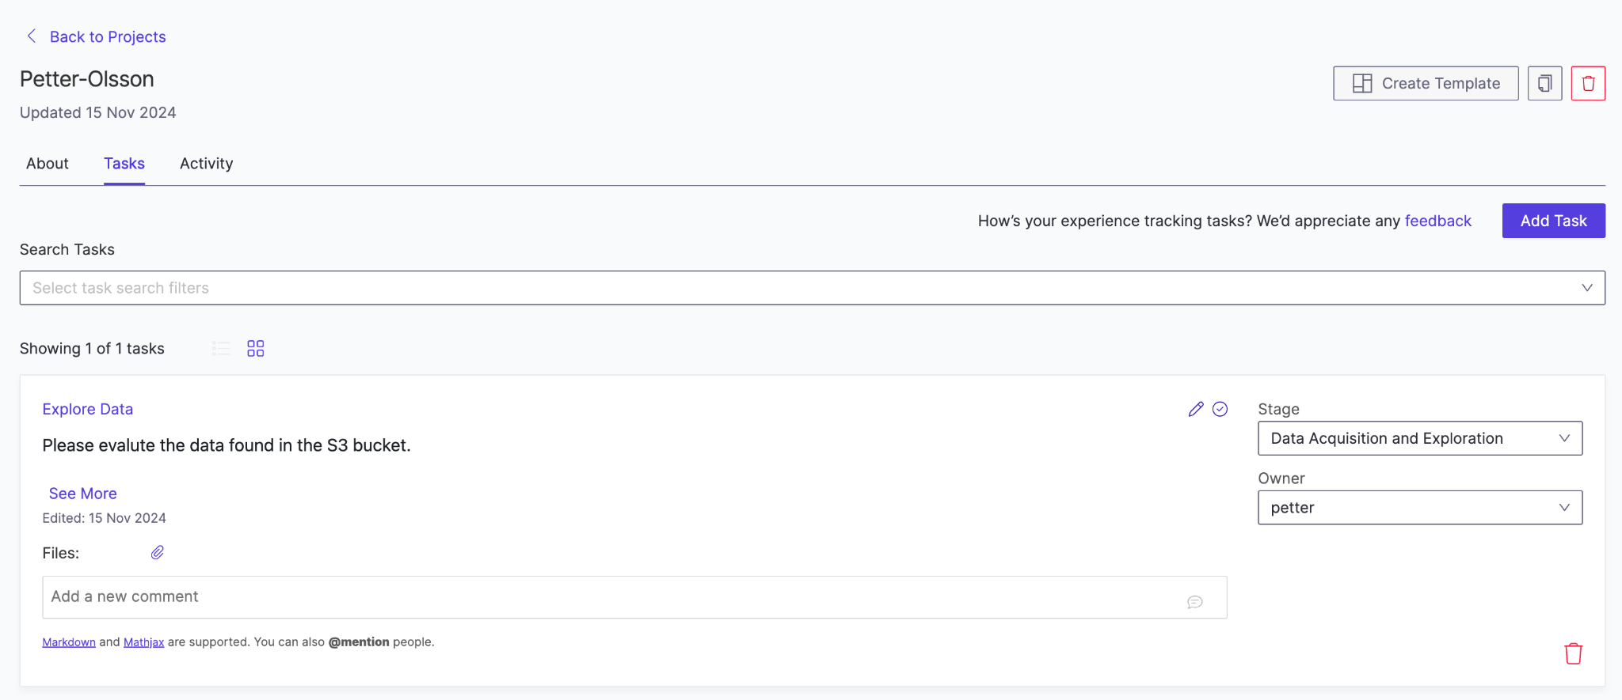

### Lab 1.3 - Add Data Source

We will now add a data connection defined by the admin of our project to query the data later. To do so, navigate to the **Data** -> **Data Sources** and click on '**Add a Data Source**'

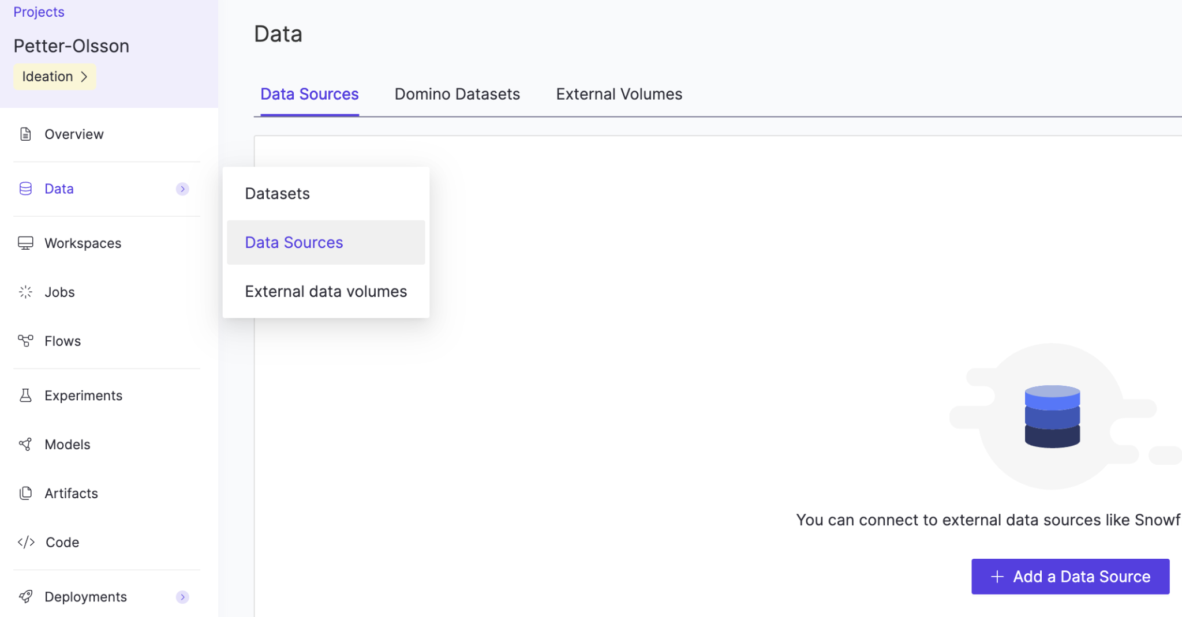

Select the **mlops-best-practices** S3 bucket connection and click Add to Project.

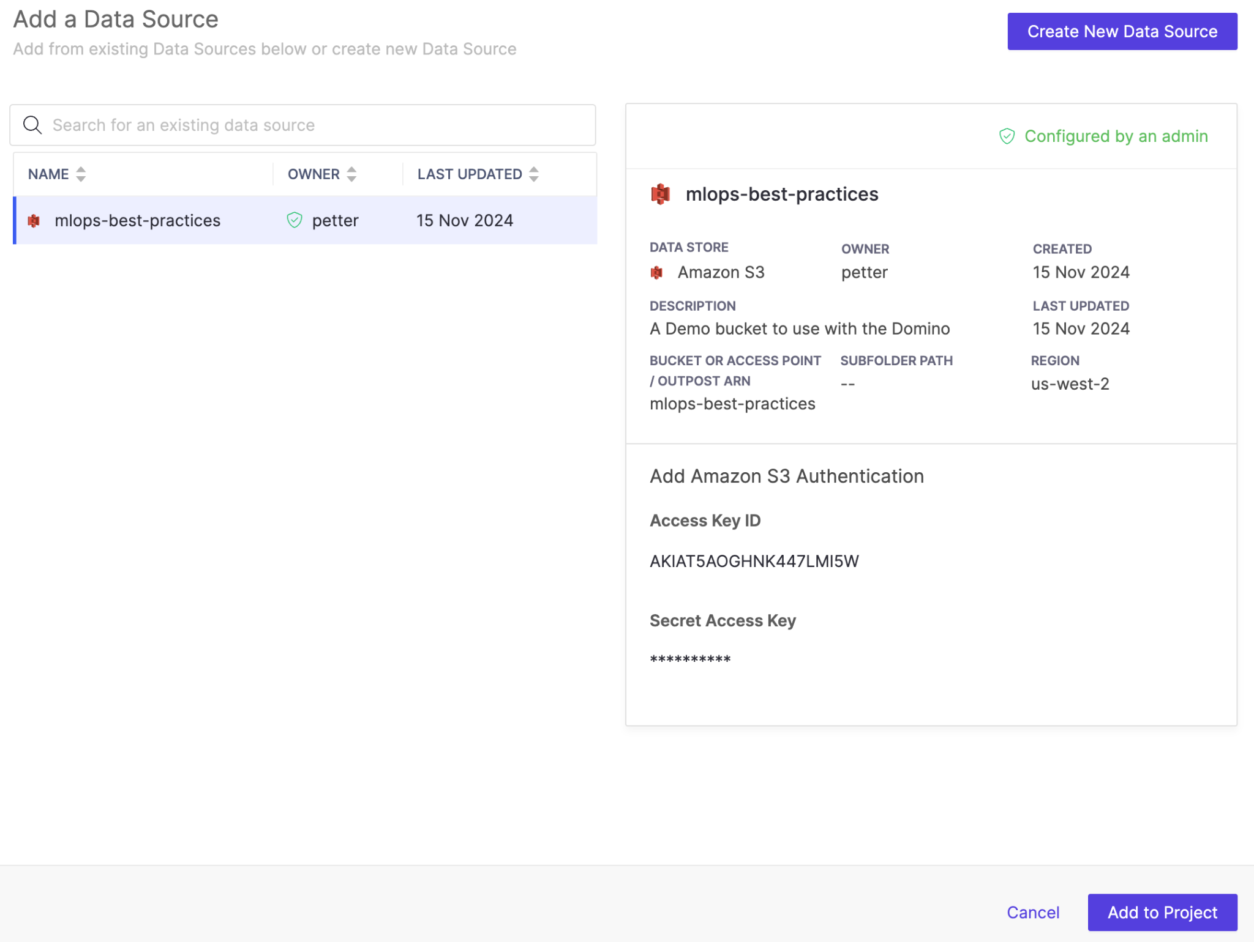

The data source should look like the image below.

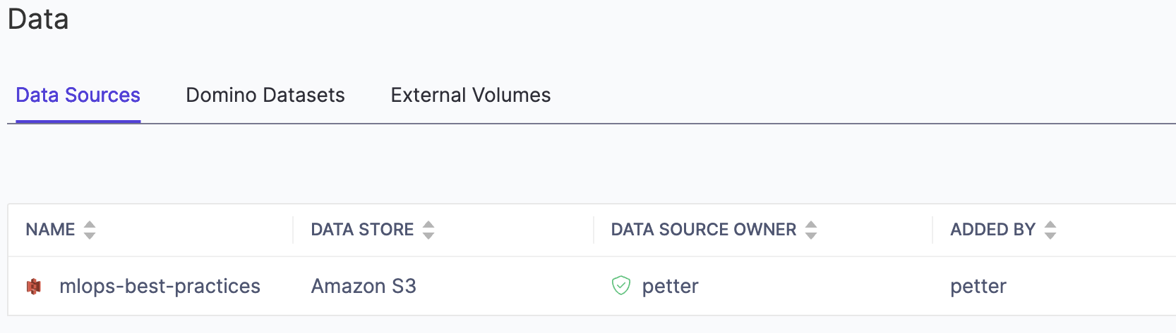

End Section 1